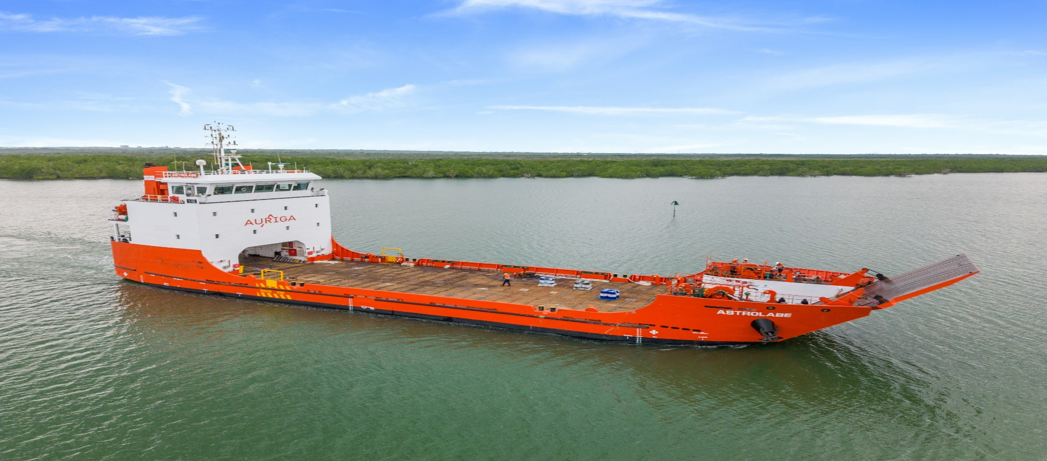

LCT ASTROLABE
Machinery and Equipment |  | 3 | Principal Particular
Main Engine | 2x Yanmar 6EY17W @590Kw |  | Port of Registry | Dampier
Generator Engine | 3 x Cummins N855- DM 240kW |  | Flag | Australia
Emergency Generator | Cummins 68T 80kW |  | IMO Number  Call Sign | 9766970  VHKL
Bow Thruster | 200kW Double Direction |  | Year Build | 2015
Steering Gear | Oceanic Marine Electro Hydraulic |  | LOA | 59.60m
Max Speed | 10 knots |  | Breadth | 15.00 m
Fuel Consumption | 5.5 m3/day |  | Draft | 2.8 m
Cranage | Electro Hydraulic 900kg SWL |  | GRT | 1136
Winches | 2 x YM1F32/3 Hydraulic Windlass |  | Displacement | 1925t
Landing Craft

Cargo Capacities |  |  | Discharge Rates
Cargo Fresh Water | 388.6m3 |  | Cargo Fuel pumps | 2x 80m3 @0.8mpa
Container Stack Weight | 45t per 20ft |  | Cargo Water pumps | 2x 65m3 @0.65mpa
Ballast Capacity | 396.4m3
Cargo Fuel Oil | 645.9m3
Outside Deck Area | 533.8m2
Under Cover Deck Area | 73.8m2
Deck Cargo Capacity | 10t/m2

