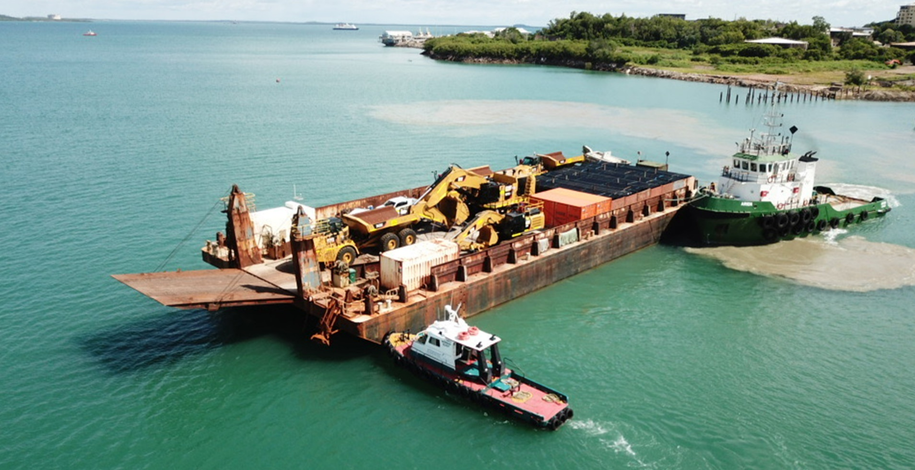OFFShore Surveyor

DP1 MULTI PURPOSE SURVEY VESSEL

|  |  |  |
| --- | --- | --- |
| Machinery and equipment | 3 | Principal Particular |
| Main Engines: Cummins QSk19 |  | Length Overall 34.00 Metre |
| Propulsion: Fixed Pitch Propellors |  | Breadth 11.04 Metres |
| Gear Box: Twindisk |  | Draft Lightship: 2.0 Metres |
| Bow Thrusters: 160hp tunnel thruster |  | No Passengers: 24 (including Master) |
| Stabilizers: 2x Veem Gryro Stabilisers |  | GRT: 393 GRT 117 NT |
| Generators: 2x Cummins QSB7’s & 1x Cummins 6BT |  | Fuel Capacity: 82,000L MGO |
| Moonpool: Custom inbuild tower |  | Fresh Water: 20,000L |
| Crane: Palfinger 15T @ 4.5m , 2T @15 Meters |  | Ballast: 60,000 |